Software Engineering

[Type the document subtitle]

[Type the abstract of the document here. The abstract is typically a short summary of the contents of the document. Type the abstract of the document here. The abstract is typically a short summary of the contents of the document.]

2013

Amenda Fernando

[Type the company name]

1/1/2013

## Acknowledgement

## Benefits of proposed system

Super easy

# Content

# Context Level

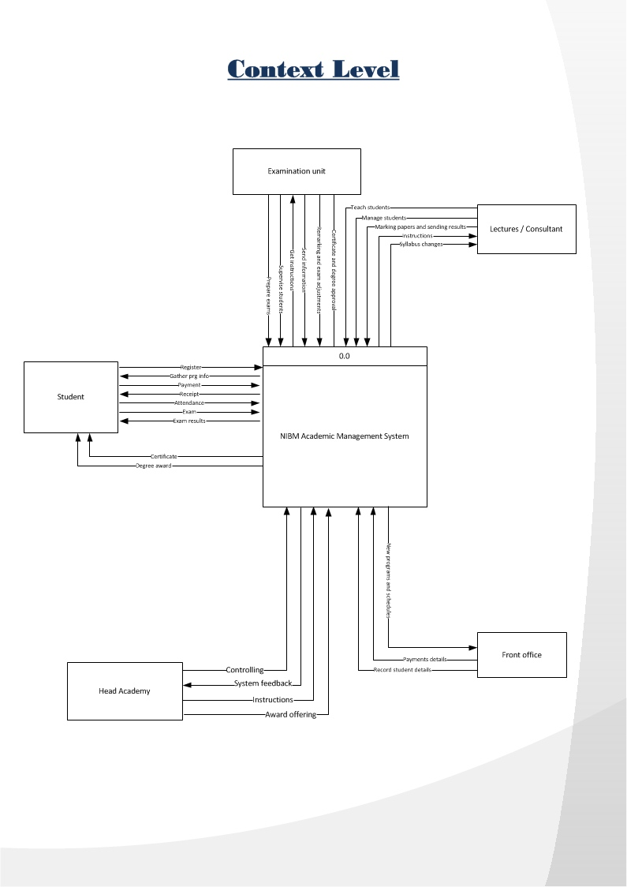

# Level 0

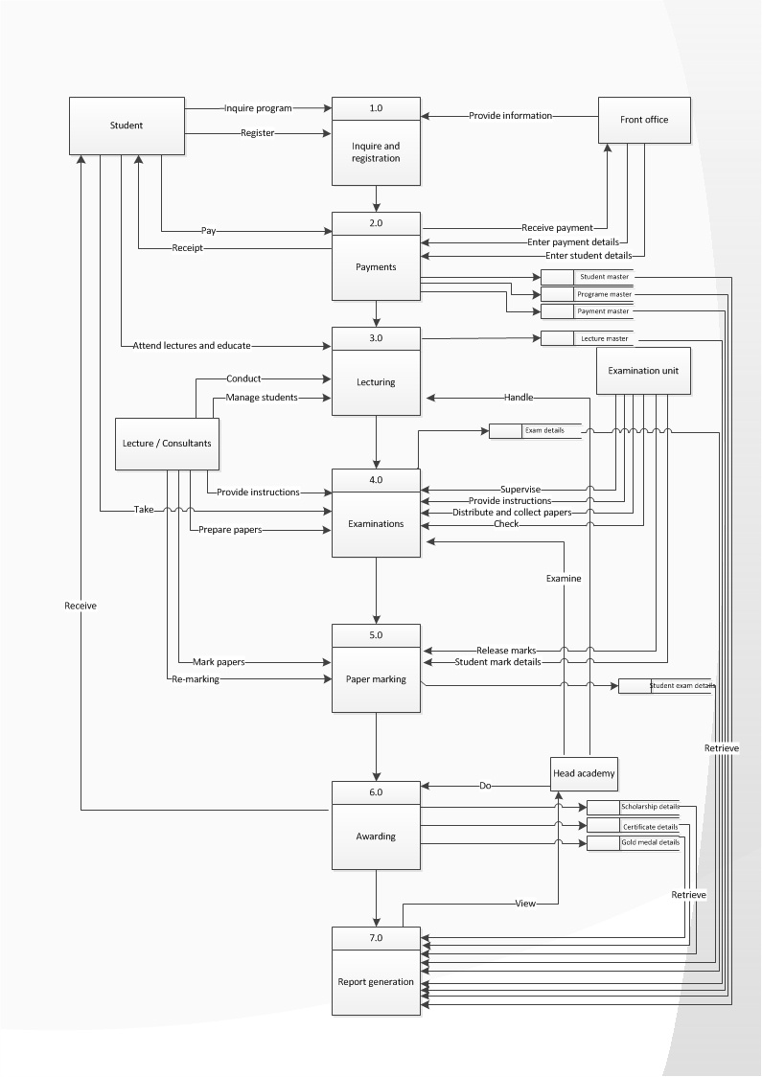

# Level 1

# File Design

|  |  |
| --- | --- |
|  |  |
|  |  |
|  |  |
|  |  |
|  |  |
|  |  |
|  |  |
|  |  |
|  |  |
|  |  |
|  |  |
|  |  |
|  |  |
|  |  |
|  |  |
|  |  |
|  |  |
|  |  |

**File No : - F01**

**File Name : - Student_Master**

**File Description : - Students’ Details**

**Record Size : - 200**

**Primary Key : -Std_ID**

**File Organization : - Index**

|  |  |  |  |  |
| --- | --- | --- | --- | --- |
| **Field No** | **Field Name** | **Description** | **Field Type** | **Field Size** |
| 01 | Std_ID | Student Number | Number | 12 |
| 02 | Std_Name | Student Name | Text | 30 |
| 03 | NIC | NIC Number | Text | 10 |
| 04 | Gender | Gender | Text | 6 |
| 05 | DOB | Date Of Birth | Date | 10 |
| 06 | Address | Address | Text | 60 |
| 07 | Contact_No | Contact Number | Number | 10 |
| 08 | Email | E-mail | Text | 25 |
| 09 | Regi_Date | Registration Date | Date | 20 |
| 10 | Regi_Time | Registration Time | Text | 8 |

**File No : - F03**

**File Name : - Lecturer_Master**

**File Description : - Lecturer Details**

**Record Size : - 80**

**Primary Key : - Lect_ID**

**File Organization : - Index**

|  |  |  |  |  |
| --- | --- | --- | --- | --- |
| **Field No** | **Field Name** | **Description** | **Field Type** | **Field Size** |
| 01 | Lect_ID | Lecturer ID | Text | 10 |
| 02 | Name | Lecturer’s Name | Text | 20 |
| 03 | Division | Division | Text | 40 |
| 04 | Center | Lecturer’s Center | Text | 10 |

|  |  |  |  |  |
| --- | --- | --- | --- | --- |
| **Field No** | **Field Name** | **Description** | **Field Type** | **Field Size** |
| 01 | Pgrm_ID | Programme Code | Text | 4 |
| 02 | Division | Division | Text | 40 |
| 03 | Type | Programme Type | Text | 25 |
| 04 | Prg_Name | Programme Name | Text | 45 |
| 05 | Prg_Director | Programme Director’s Name | Text | 20 |

**File No : - F04**

**File Description : - Programme_Master**

**Record Size : - 135**

**Primary Key : - prgm_ID**

**File Organization : - Index**

**File No : - F04**

**File Name : - Examination Board_Master**

**File Description : - Examination Board Details**

**Record Size : - 35**

**Primary Key : - Exam_Off_ID**

**File Organization : - Index**

|  |  |  |  |  |
| --- | --- | --- | --- | --- |
| **Field No** | **Field Name** | **Description** | **Field Type** | **Field Size** |
| 01 | ExamOff_ID | Exam Officer ID | Text | 5 |
| 02 | ExamOff_Name | Exam Officer Name | Text | 20 |
| 03 | Contact_No | Contact Number | Number | 10 |

**File No : - F05**

**File Name : Unit Head_Details**

**File Description : - Unit Head Details**

**Record Size : - 50**

**Primary Key : - UHead _ID**

**Foreign Key : - Lect_ID**

**File Organization : - Sequential**

|  |  |  |  |  |
| --- | --- | --- | --- | --- |
| **Field No** | **Field Name** | **Description** | **Field Type** | **Field Size** |
| 01 | UHead_ID | Unit Head ID | Text | 5 |
| 02 | Lect_ID | Lecturer ID | Text | 5 |
| 03 | Name | Unit Head’s Name | Text | 20 |
| 04 | Center | Center | Text | 10 |
| 05 | Contact_No | Contact Number | Number | 10 |

**File No : - F06**

**File Name : - Module_Deatils**

**File Description : - Module Details**

**Record Size : - 30**

**Primary Key : - Mdl_ID**

**Foreign Key : - Lect_ID**

**File Organization : - Sequential**

|  |  |  |  |  |
| --- | --- | --- | --- | --- |
| **Field No** | **Field Name** | **Description** | **Field Type** | **Field Size** |
| 01 | Mdl_ID | Module ID | Text | 4 |
| 02 | Module_Name | Module Name | Text | 20 |
| 03 | Lect_ID | Lecturer ID | Text | 5 |
| 04 | Credit_Points | Credit Points | Number | 1 |

**File No : - F07**

**File Name : - Student Batch_Details**

**File Description : - Student Batch Details**

**Record Size : 18**

**Foreign Key : -Std_ID,Batch_Code, Pgrm_Code**

**File Organization : - Sequential**

|  |  |  |  |  |
| --- | --- | --- | --- | --- |
| **Field No** | **Field Name** | **Description** | **Field Type** | **Field Size** |
| 01 | Std_ID | Student Number | Number | 8 |
| 02 | Batch_Code | Batch Code | Number | 6 |
| 03 | Pgrm_Code | Programme Code | Text | 4 |

**File No : - F08**

**File Name : - Exam_Details**

**File Description : - Examinations’ Details**

**Record Size : - 38**

**Primary Key : -Exam_Code**

**Foreign Key : - Mdl_ID**

**File Organization : - Sequential**

|  |  |  |  |  |
| --- | --- | --- | --- | --- |
| **Field No** | **Field Name** | **Description** | **Field Type** | **Field Size** |
| 01 | Exam_Code | Examination Code | Number | 6 |
| 02 | Module_ID | Module ID | Text | 4 |
| 03 | Date | Date | Date | 28 |

**File No : - F09**

**File Name : - Batch_Details**

**File Description : - Batch Details**

**Record Size : - 85**

**Primary Key : - The row itself**

**Foreign Key : - Pgrm_Code**

**File Organization : - Sequential**

|  |  |  |  |  |
| --- | --- | --- | --- | --- |
| **Field No** | **Field Name** | **Description** | **Field Type** | **Field Size** |
| 01 | Batch_Code | Batch Code | Number | 6 |
| 02 | Pgrm_Code | Programme Code | Text | 4 |
| 03 | Start_Date | Start Date | Date | 20 |
| 04 | End_Date | End Date | Date | 20 |
| 05 | Status | Status | Text | 6 |
| 06 | Center | Center of given batch | Text | 10 |
| 07 | Programme_Director | Programme Director’s Name | Text | 20 |

**File No : - F10**

**File Name : - Student Exam_Details**

**File Description : - Students’ Examination Details**

**Record Size : - 18**

**Foreign Key : - Std_ID,Exam_Code**

**File Organization : - Sequential**

|  |  |  |  |  |
| --- | --- | --- | --- | --- |
| **Field No** | **Field Name** | **Description** | **Field Type** | **Field Size** |
| 01 | Std_ID | Student Number | Number | 8 |
| 02 | Exam_Code | Examination Code | Number | 6 |
| 03 | Status | Student’s Exam Participation | Text | 4 |

**File No : - F11**

**File Name : - Payment master**

**File Description : - Students’ payment Details**

**Record Size : - 36**

**Primary Key :- Payment_ID**

**Foreign Key : - Std_ID,Exam_Code**

**File Organization : - Sequential**

|  |  |  |  |  |
| --- | --- | --- | --- | --- |
| **Field No** | **Field Name** | **Description** | **Field Type** | **Field Size** |
| 01 | SPayment_ID | Student Payment ID number | Number | 8 |
| 02 | Std_ID | Student Number | Number | 8 |
| 03 | Date | Payment date | Date | 20 |

**File No : - F12**

**File Name : - Payment_Details**

**File Description : - Payment Details**

**Record Size : - 291**

**Primary Key :- Payment_ID**

**Foreign Key : - Std_ID**

**File Organization : - Sequential**

|  |  |  |  |  |
| --- | --- | --- | --- | --- |
| **Field No** | **Field Name** | **Description** | **Field Type** | **Field Size** |
| 01 | Payment_ID | Payment ID number | Number | 8 |
| 02 | Std_ID | Student Number | Number | 8 |
| 03 | Date | Payment date | Date | 20 |
| 04 | Desc | Description | Text | 255 |

**File No : - F13**

**File Name : - Student_Suspension_Details**

**File Description : - Students’ suspension Details**

**Record Size : - 291**

**Primary Key :- S_ID**

**Foreign Key : - Std_ID**

**File Organization : - Sequential**

|  |  |  |  |  |
| --- | --- | --- | --- | --- |
| **Field No** | **Field Name** | **Description** | **Field Type** | **Field Size** |
| 01 | S_ID | Student Suspension ID number | Number | 8 |
| 02 | Std_ID | Student Number | Number | 8 |
| 03 | Date | Payment date | Date | 20 |
| 04 | Des | Suspension description | Text | 255 |

**File No : - F14**

**File Name : - certificate_receiver_Details**

**File Description : - certificate received details of students**

**Record Size : - 46**

**Primary Key :- C_ID**

**Foreign Key : - Std_ID, Prgm_ID**

**File Organization : - Sequential**

|  |  |  |  |  |
| --- | --- | --- | --- | --- |
| **Field No** | **Field Name** | **Description** | **Field Type** | **Field Size** |
| 01 | C_ID | Certificate ID number | Number | 8 |
| 02 | Std_ID | Student Number | Number | 8 |
| 03 | Prgm_ID | Course ID | Text | 10 |
| 03 | Date | Payment date | Date | 20 |

**File No : - F15**

**File Name : - Gold_Medal_Details**

**File Description : - gold medal awarded details**

**Record Size : - 42**

**Primary Key :- M_ID**

**Foreign Key : - Std_ID**

**File Organization : - Sequential**

|  |  |  |  |  |
| --- | --- | --- | --- | --- |
| **Field No** | **Field Name** | **Description** | **Field Type** | **Field Size** |
| 01 | G_ID | Gold medal ID number | Number | 8 |
| 02 | Std_ID | Student Number | Number | 8 |
| 03 | Batch_code | Batch code | Number | 6 |
| 04 | Date | Award date | Date | 20 |

**File No : - F16**

**File Name : - Scholarship_Details**

**File Description : - Students’ scholarship Details**

**Record Size : - 291**

**Primary Key :- Sco_ID**

**Foreign Key : - Std_ID**

**File Organization : - Sequential**

|  |  |  |  |  |
| --- | --- | --- | --- | --- |
| **Field No** | **Field Name** | **Description** | **Field Type** | **Field Size** |
| 01 | Sco_ID | Student scholarship ID number | Number | 8 |
| 02 | Std_ID | Student Number | Number | 8 |
| 03 | Date | Payment date | Date | 20 |
| 04 | Des | Description | Text | 255 |

**File No : - F17**

**File Name : - Student_Attendance_Details**

**File Description : - Students’ attendance Details**

**Record Size : - 28**

**Primary Key :- Date**

**Foreign Key : - Std_ID**

**File Organization : - Sequential**

|  |  |  |  |  |
| --- | --- | --- | --- | --- |
| **Field No** | **Field Name** | **Description** | **Field Type** | **Field Size** |
| 01 | Date | Date | Date | 20 |
| 02 | Std_ID | Student Number | Number | 8 |

**File No : - F18**

**File Name : - Lec_Attendance_Details**

**File Description : - Lecturers attendance Details**

**Record Size : - 28**

**Primary Key :- Date**

**Foreign Key : - Lec_ID**

**File Organization : - Sequential**

|  |  |  |  |  |
| --- | --- | --- | --- | --- |
| **Field No** | **Field Name** | **Description** | **Field Type** | **Field Size** |
| 01 | Date | Date | Date | 20 |
| 02 | Lec_ID | Student Number | Number | 8 |

# SQL Commands